Accessibility

Overview
All course content and activities within a course must be accessible to all learners regardless of learning ability and preference. This means that every learner, including those with specific learning needs and disabilities (e.g., visual impairment, hearing impairment, etc.), needs to be able to access, navigate and interact with all course content, learning activities, and associated materials and tools with ease. In TAMU’s instance of the Canvas digital learning environment, this can be monitored using Ally or Panorama. In Mays courses that use the CidiLabs platform, the accessibility can also be monitored and remediated within the DesignPLUS tool.
Accessible course design includes ensuring that course navigations are easy to use, practicing accessible web design, captioning all media, and properly editing static content (e.g., text documents, presentation slides, spreadsheets, etc.).
This guide provides guidelines on ways to produce accessible instructional content for all learners. It includes the following sections:
- The Ally Tool in Canvas
- Panorama Tool in Canvas
- TidyUP Tool in Canvas
- What does TidyUp do?
- Enable TidyUp on your Canvas course
- Scan Files
- Organizing and Editing Canvas Course with TidyUp
- TidyUp Search Feature
- Before Deleting Unused Files
- Question Banks files
- Download Selected Canvas Content, File and/or Folder Before Deleting
- Review and Delete Content
- DesignPLUS Accessibility and Usability Tools
- PDF Remediation
- Course Navigation and Usability
- Accessible Web Design
- Accessible Instructional Media
- Ensuring Accessibility of Static Content
- Considerations for Non-Standard Technologies
- Considerations for the Diverse Needs of Learners

The Ally Tool in Canvas
Ally is an integrated tool in Canvas that is designed to help you improve the accessibility of your course documents and images. Ally evaluates all the content in a Canvas course, assigns an accessibility score, and provides recommended steps to take to improve accessibility of any content that does not meet accessibility guidelines.
Ally checks for things like:
- Alt text on images, charts, and tables
- Compatibility of PDF documents with screen readers
- Ease of navigation of static documents, such as the use of headings
Ally also provides learners with the option to choose between different formats of documents, so they can select the version that best fits their learning needs and preferences.
Inside your Canvas course, Ally will display red, yellow, light or dark green icons next to each content item to indicate the accessibility of that item. Clicking on the icon will bring more details about the accessibility of that item. For each error, Ally will give detailed instructions on how to resolve the issue(s). For best practice, enable the Ally Accessibility Report in the course settings for each TAMU Canvas course. Additionally, TAMU changes to content or Canvas assets should be made outside of the Ally window, so that those updates carry forward to subsequent terms. Follow a step-by-step process on Ally: Canvas Accessibility Tool.

Panorama Tool in Canvas
Panorama is an innovative accessibility tool integrated into Canvas that supports inclusive digital learning by helping instructors identify and address accessibility barriers in course content. It automatically scans files uploaded to Canvas and provides comprehensive accessibility reports, including readability scores, document structure analysis, and clear recommendations for remediation.
In addition to identifying accessibility issues, Panorama offers remediation assistance and generates alternative file formats, such as audio, ePub, HTML, and tagged PDFs, that students can download directly from course pages. These options allow students to access materials in formats that best support their individual learning needs.
Note: Not all accessibility issues can be resolved using Panorama. Some issues may require editing in the original (native) application, such as using Adobe Acrobat Pro to remediate PDF files.

Canvas Access to Panorama
Panorama is enabled by default in all TAMU Canvas courses. Instructors will see accessibility indicators next to supported file types within their course content.
Instructors can generate and view detailed accessibility results by clicking the Panorama link in the Canvas course navigation menu.
For step-by-step guidance on enabling and using Panorama in Canvas, use the Accessibility Checker and Remediation Aid.
Students can view and download alternative file formats by clicking on the Panorama icon next to files in Canvas. These alternative formats are automatically generated and updated whenever the original file is modified.
More Information
For more details on using Panorama, go to the Panorama for Instructors and Panorama for Students pages on the YuJa Panorama LMS Accessibility Platform.

TidyUP Tool in Canvas
TidyUP is a content cleanup tool for Canvas courses that provides a quick way to view all the content in your course and clean out anything that is no longer needed. Identifying and deleting extra files, folders, pages, or assignments that are no longer used makes your course easier to manage and more usable for everyone!
CidiLab's - TidyUp has been added to Mays Business School Canvas to help faculty clean up old/unused files from Canvas and also improve Accessibility Scores. This can be very helpful for faculty who have reused courses by copying course content into new courses. For detailed information, refer to the TidyUp User Guide.

What does TidyUp do?
- It is a course cleanup tool for Canvas.
- It identifies and removes unused files and content.
- It locates duplicate files and content.
- It organizes your course files and folders.
- It ensures intuitive, consistent file and content naming.
- It can be used to meet the Flex Online Quality Review standard related to course files organization.
- It supports course mapping.

Enable TidyUp on your Canvas course
TidyUp is an instructor-only feature and will not be visible to students. Teacher and TA users can add TidyUp to a Canvas course by using these instructions:
- Log into your Canvas account and navigate to the course where you want to add TidyUp.
- In the course menu, scroll down and click Settings, and then click the Navigation tab.
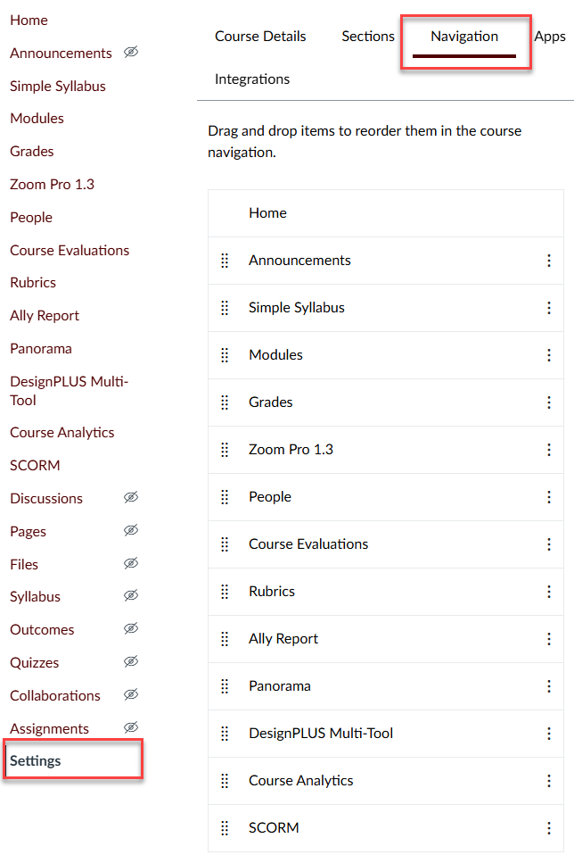
Figure 1: Canvas Setting on navigation menu
- Find TidyUp in the list of navigation items and click the three dots next to it. Next, select Enable. Alternatively, drag and drop TidyUp from the hidden items section to the active items section above.
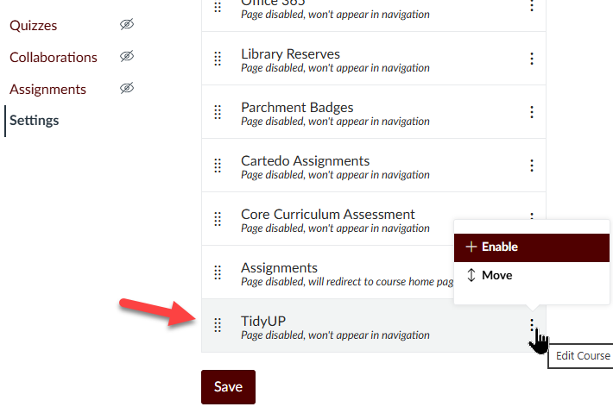
Figure 2: Enabling TidyUp on Canvas Navigation settings
- Scroll to the bottom of the page and click the Save button to apply the changes.
- After saving, check your course navigation menu to ensure that TidyUp is now visible and accessible.
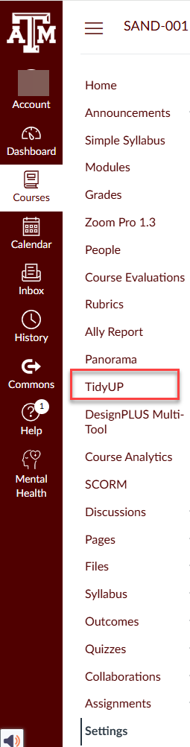
Figure 3: Checking for TidyUp link on Canvas Navigation menu

Scan Files
- After adding TidyUp to your course menu, click on the TidyUp tool.
- When the tool launches, click the Scan button to analyze your course content.
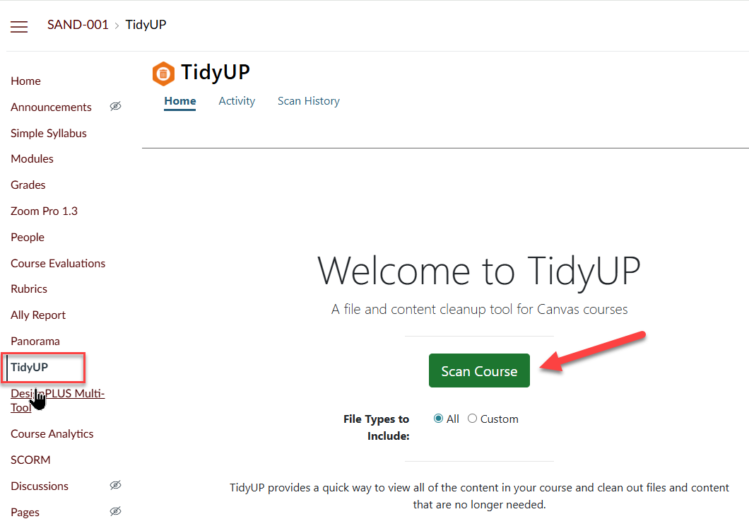
Figure 4: TidyUP home screen in Canvas highlighting the course navigation link and the Scan Course button
- Once the scan is complete, TidyUp will display a list of every single file in your course. For each file, it will show where it is used within the course, such as on specific pages or modules.

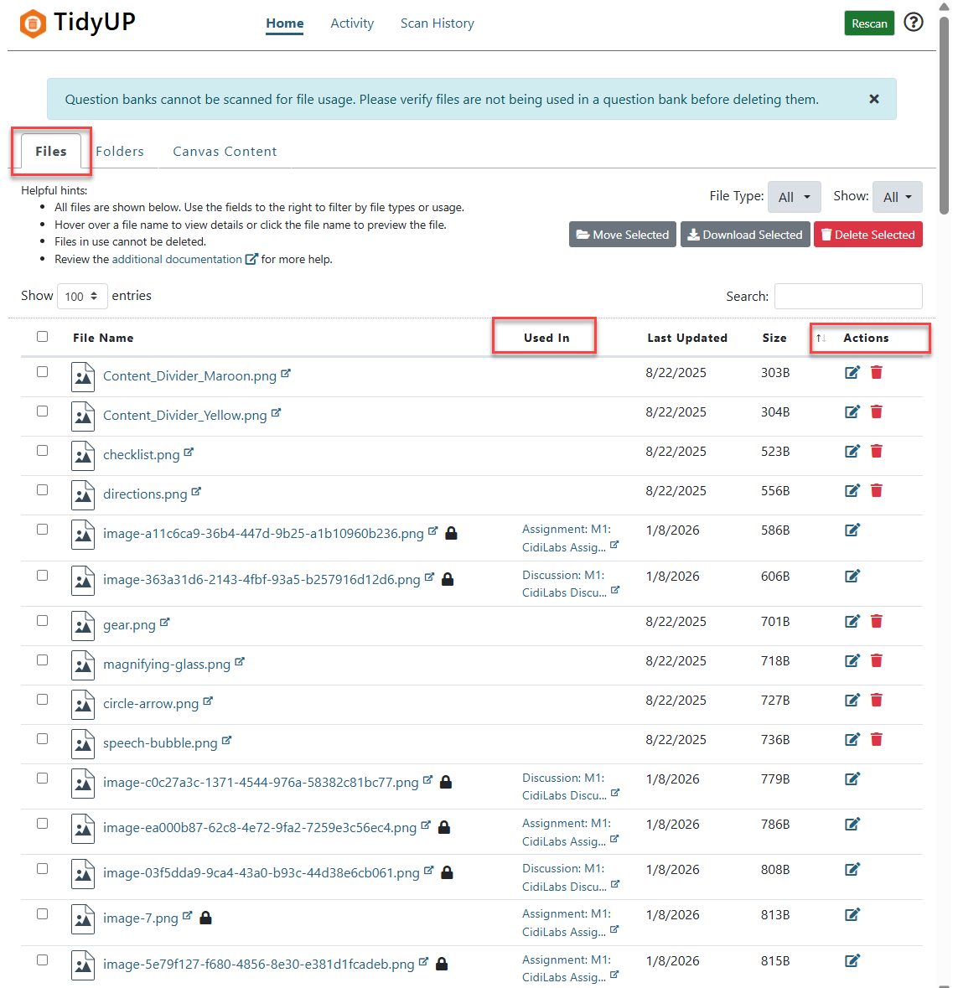
Figure 5: TidyUP Files view showing file usage status, last updated date, and available actions for managing course files

Organizing and Editing Canvas Course with TidyUp
Note: TidyUP opens by default in the Files tab. You will work through the TidyUP tabs in the following order:
- Canvas Content
- Files
- Folders.
After completing work in each tab, use the green Rescan button to update the course scan before moving to the next tab.
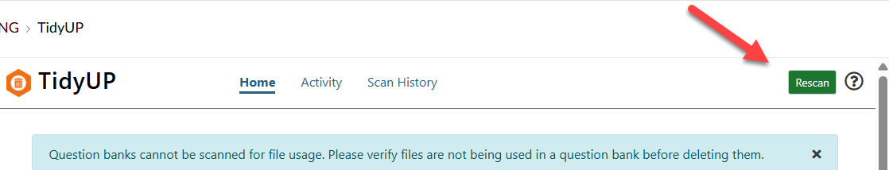
Figure 6: TidyUP Home view in Canvas. Use the Rescan button (top right) to rerun a course content scan after making updates or deleting items

Canvas Content Tab
TidyUp uses Canvas Content Icons to help you to visually identify different types of content like pages, discussions, and quizzes. You can click on any of the links to inspect what is on it and easily go back to TidyUp content list.
- On Canvas Content tab you also have the option to narrow your view even further. At the top right-side menu, you can filter out based on Publish or not, In Modules or not, and/or Has Content or not.

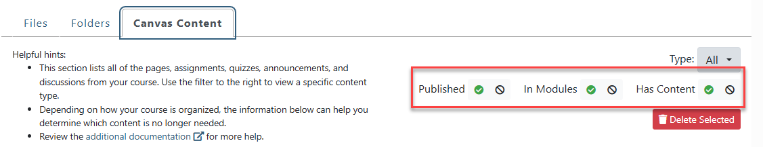
Figure 7: Using filters in the TidyUP Canvas Content tab to review and manage course content
- TidyUP also allows you to filter content by type, such as Page, Assignment, Quiz, Discussion, and Announcement. This feature helps ensure consistent naming conventions and makes it easier to identify and remove unused or duplicate content.
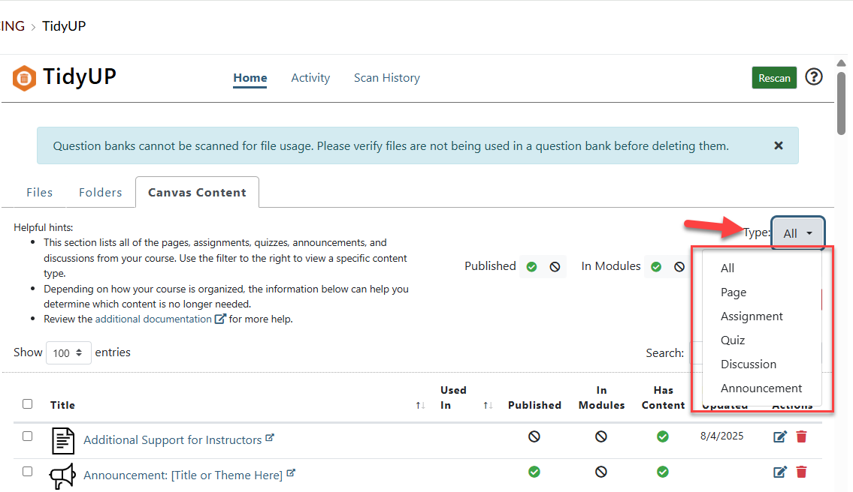
Figure 8: Filtering content by type in the TidyUP Canvas Content tab to review specific content items
- All items in the Canvas Content tab include a trash can icon. Unlike files and folders, if you delete a content item by mistake, you can restore it using Canvas’s Undelete feature. From your course homepage, add /undelete to the end of your course URL to view and restore deleted items.
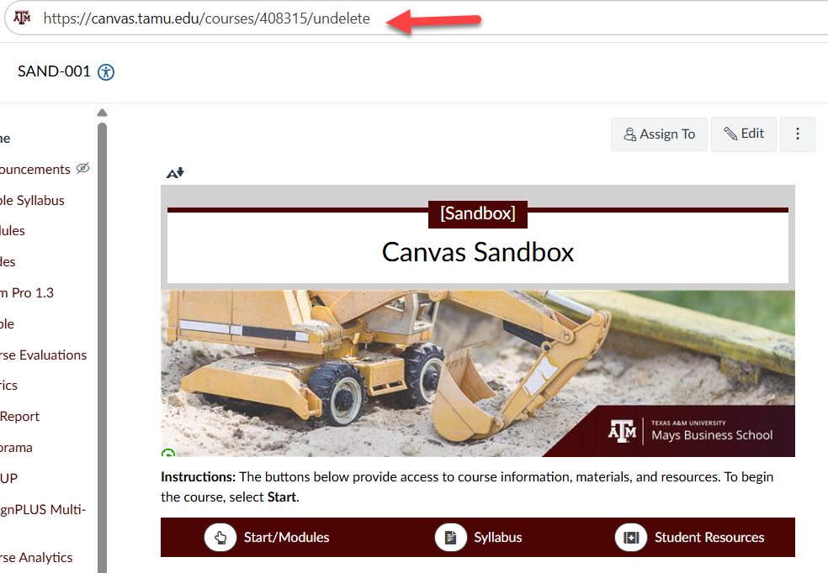
Figure 9: Accessing the Canvas Undelete feature by adding /undelete to the end of a course URL
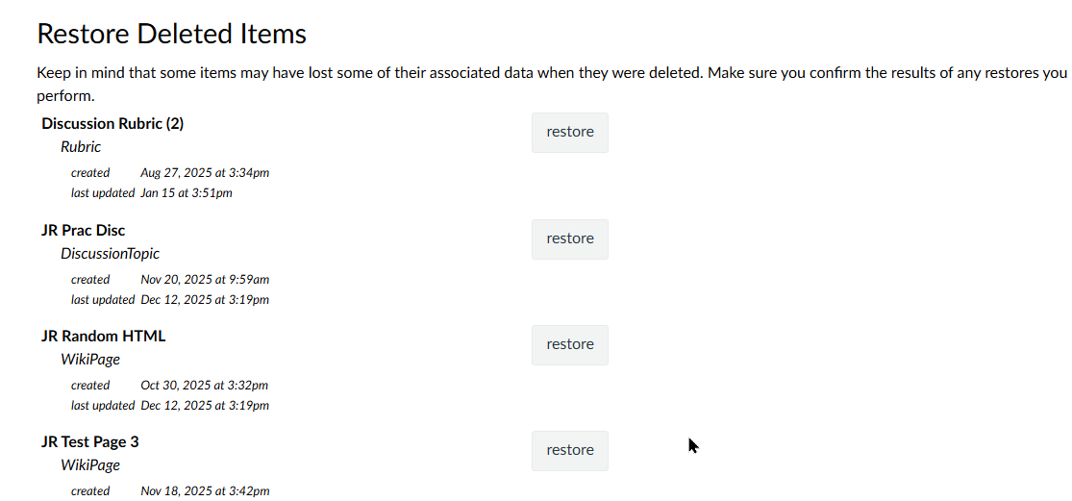
Figure 10: Canvas Undelete page showing deleted items that can be restored to the course

Files Tab
- The scanning default is to show all files. To filter only for Unused files, click on the dropdown bottom beside Show at the top right side of the page and select “Unused Files”.
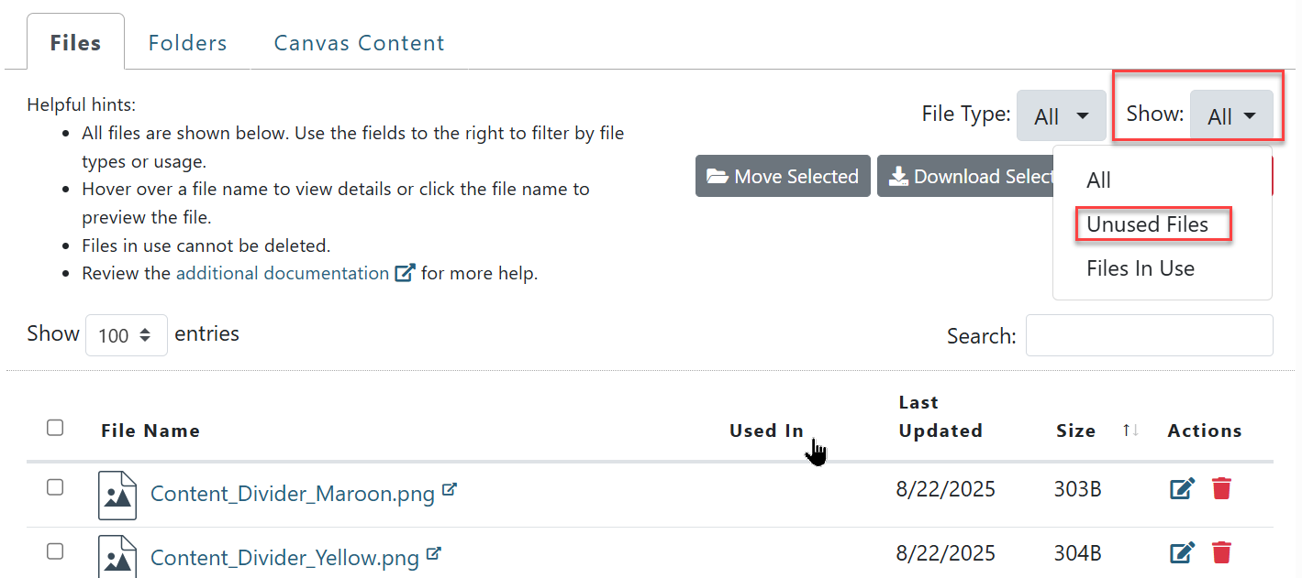
Figure 11: TidyUP Files view highlighting the Show filter set to Unused Files to identify files that are not in use
- Use the Edit button (pencil icon), located under the Actions on the table, to rename files for clarity and to ensure consistent file content-naming standards. Whenever you rename a file, be sure to verify that any existing links are not broken.
- Organize files by selecting multiple items and moving them to any existing folder. Select the files you want to move, click Move Selected, and choose the destination folder from the Move to dropdown menu.
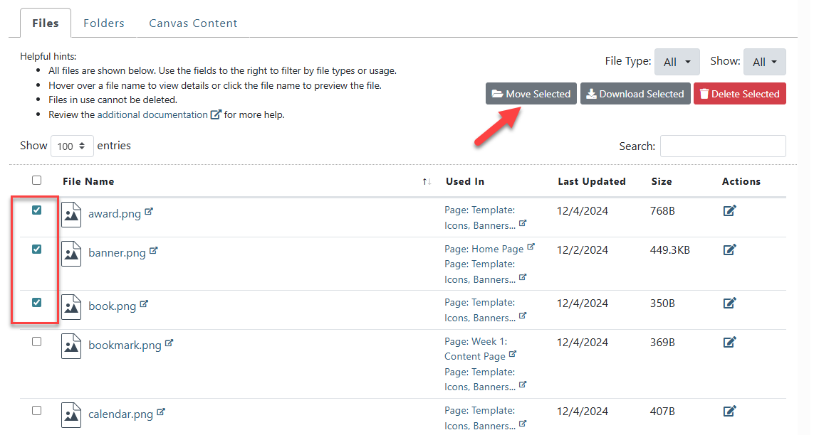
Figure 12: Selecting multiple files in TidyUP and using Move Selected to organize files into folders
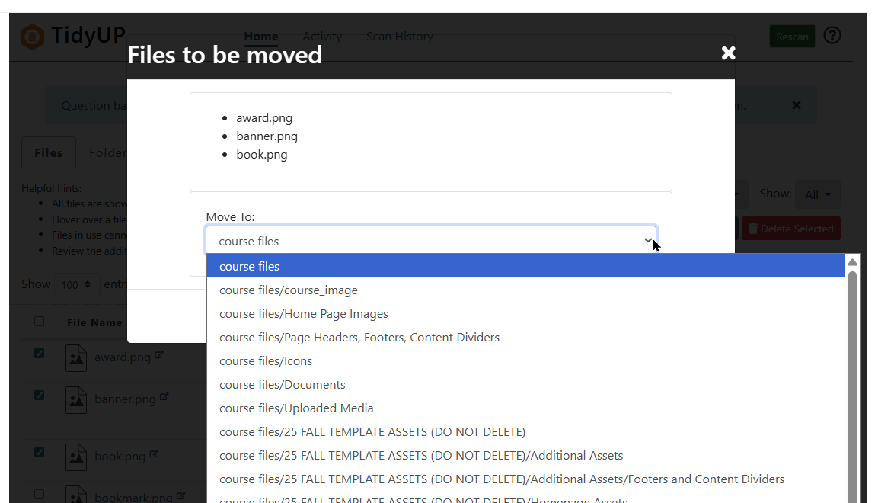
Figure 13: Choosing a destination folder when moving selected files in TidyUP

Folders Tab
When scanning folders, click the Empty link in the top-right menu to view a list of empty folders. This list shows whether a folder contains any files or nested subfolders. Select the files and delete them.
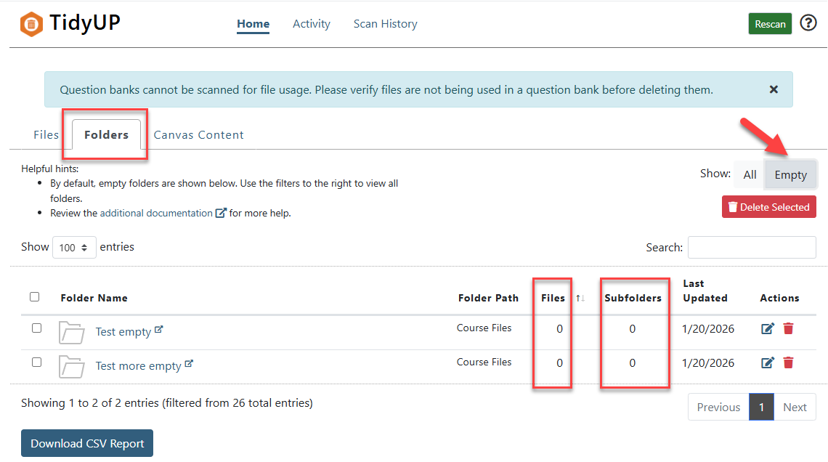
Figure 14: Using the Empty filter in TidyUP to identify folders that contain no files or subfolders

TidyUp Search Feature
In TidyUp, you can use the search feature to identify duplicate files.
- Canvas stores duplicate files with the extension –1. Enter –1 in the search field to generate a list of duplicate files.
- If content has been imported more than once, Canvas assigns the extension –2.
- Use the keyword copy to locate files that were duplicated and not deleted.
- Use (2) to search for pages that share the same name.

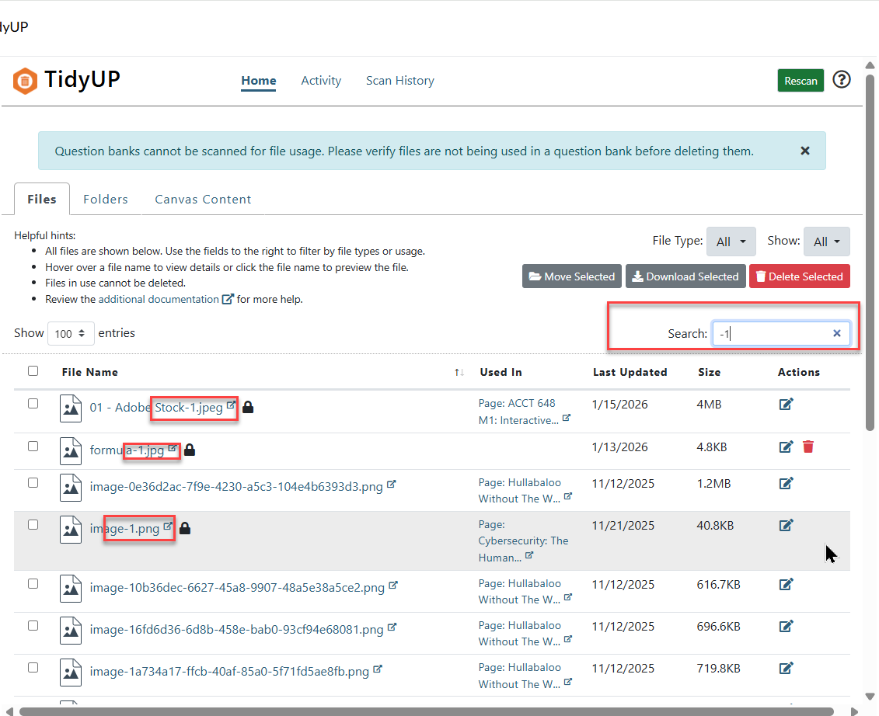
Figure 15: TidyUP Files view using the search field to locate specific files by name
Note: As a best practice, after using TidyUP, run the Canvas Link Validator to ensure that all course links are working correctly.

Before Deleting Unused Files
Important: Anything selected for deletion should be carefully reviewed before deleting. Content deleted using TidyUP cannot be restored through the TidyUP tool itself. As a best practice, before deleting content in bulk, download a copy to your One Drive for future reference. If you are concerned about not being able to restore something you might accidentally delete, it is recommended that you make a backup of your course before deleting anything. Also, take a moment to learn about TidyUp Best Practices.
Note: If a small number of items are deleted by mistake, Canvas provides a recovery option through its Undelete feature. To access it, go to your course homepage and add \undelete to the end of the course URL. This will display a list of deleted items that can be restored.

Question Banks files are not recognized as “in use”
Important: Question banks cannot be scanned for file usage. It is critical to verify files are not being used in a question bank before deleting them. If you hover over the filename for the image, TidyUp will show you a preview of the image to help you ascertain if it is still needed or not.
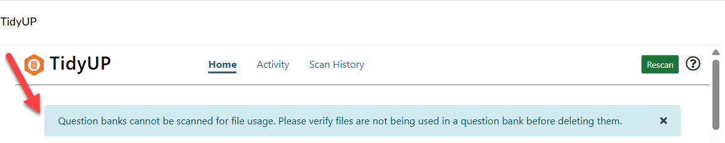
Figure 16: TidyUp system warning for Question Banks

Workarounds to protect Question Bank Files. You may:
- Encourage faculty to use TidyUp for their classes.
- Add “QB” (Question Banks) somewhere in the file name.
- Add the file to a hidden/unpublished page or
- Store files in a clearly labeled folder that can be easily recognized and ignored during scans. For that, go to the Folders tab at the top menu.
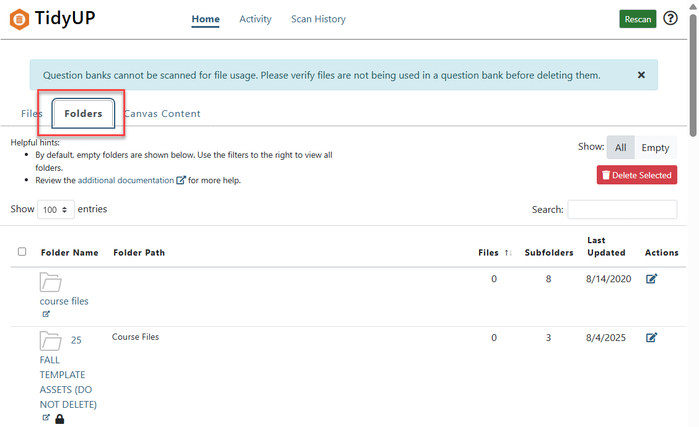
Figure 17: TidyUP Folders view displaying folders and their contents to help identify empty or unused folders
- Selecting the editing pencil icon under Actions allows you to rename a folder or mark it as Hidden, Unpublished, or Ignore folder contents in TidyUP scans. To exclude your Question Banks folder from scans, select the Ignore folder contents option.
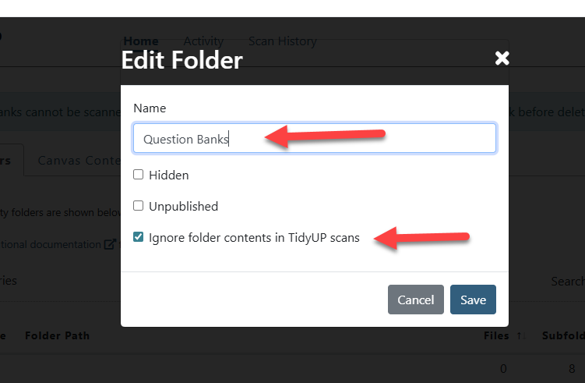
Figure 18: Editing a folder in TidyUP to rename it and exclude its contents from course scans

Download Selected Canvas Content, File and/or Folder Before Deleting
Once the scan and search are complete, select the checkbox in the File Name column to select all listed files (up to 100 files per download). If additional pages are available, repeat the process to download all files. Then click Download Selected and save the files to your One Drive or another secure, easily accessible location. This is a safe feature for bulk deletion.
- Should you delete any file or folder by mistake, use the “/undelete” feature. From your course homepage, add /undelete to the end of your course URL to view and restore deleted items.
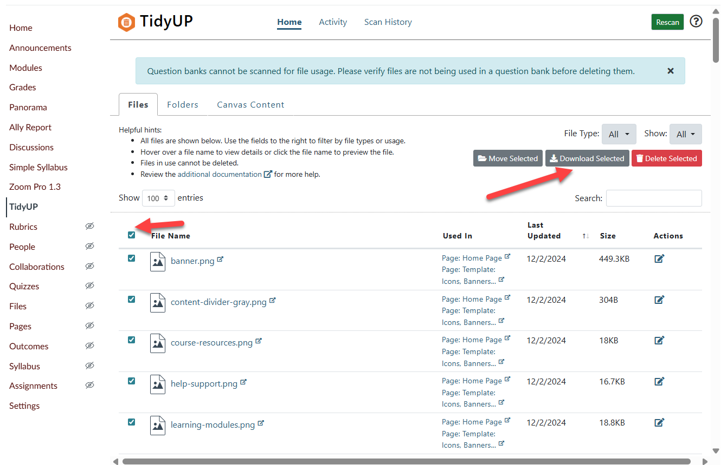
Figure 19: TidyUP Files view showing selected files and the Download Selected option for exporting multiple files at once

Review and Delete Content
Delete any unused files that are no longer needed in the course. If duplicate files exist, remove the extras and keep a single version to prevent confusion. If you would like to keep a local copy, download the file before deleting it.
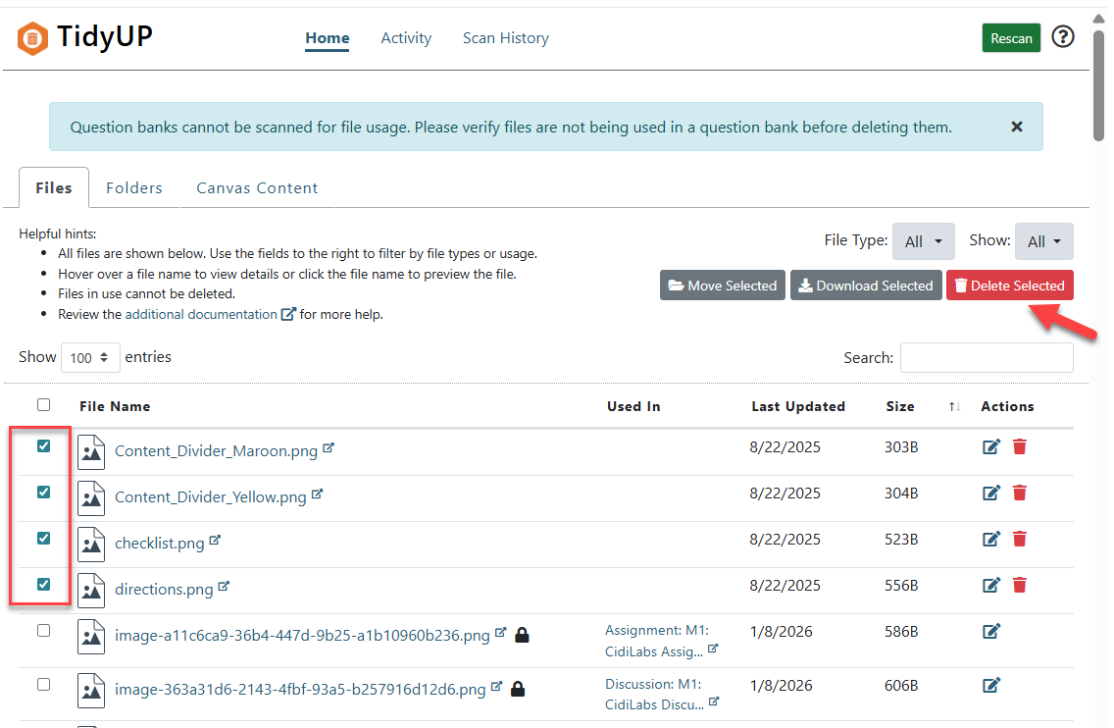
Figure 20: TidyUP Files view highlighting selected unused files and the Delete Selected option
Note: As a best practice, after using TidyUP, run the Canvas Link Validator to ensure that all course links are working correctly.
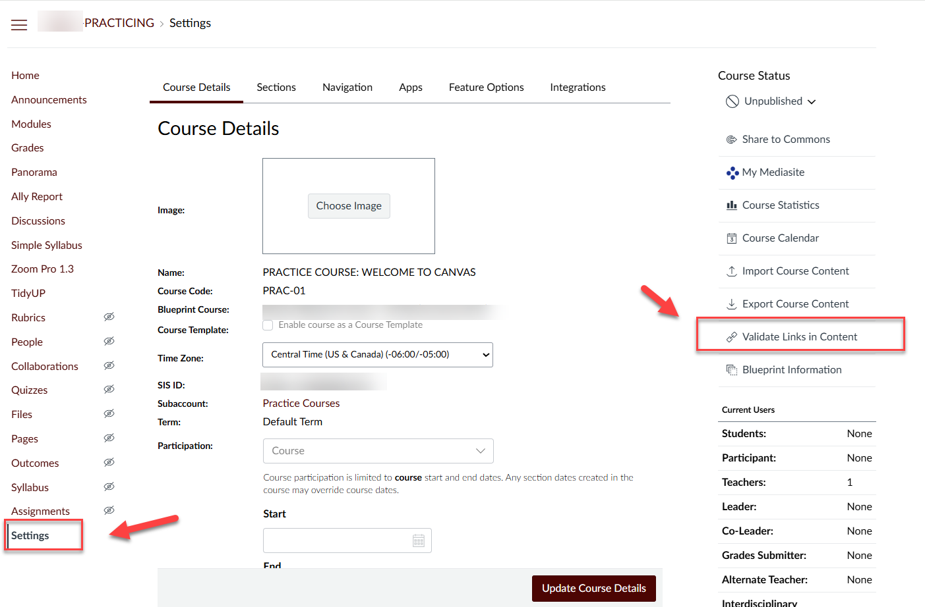
Figure 21: Canvas Settings page highlighting the Validate Links in Content option used to check for broken links after course updates

DesignPLUS Accessibility and Usability Tools

Start by navigating to the page that you want to check
- Select the Page, Assignment, Discussion, or Quiz on your Canvas course navigation menu.
- Press the Edit button on the top right of your screen.

Open the DesignPLUS Accessibility Checker
- Press on Ctrl +1 to open the CidiLabs DesignPLUS Sidebar.
- In the DesignPLUS Sidebar, select the Accessibility/Usability tab at the top.
  - A red exclamation icon indicates accessibility errors on the page.
  - A blue question mark icon indicates suggested fixes.

Accessibility and Usability Tool
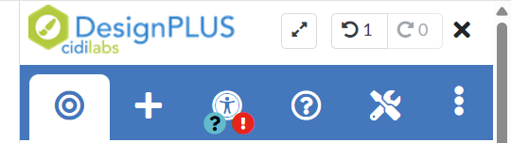
Figure 22: DesignPLUS Accessibility panel with the Accessibility checker icon
- If a red warning icon with a number appears in any of the six sections (Contrast, Heading, Image Alt, Link, Math, or Table Checker), review the flagged items for recommended accessibility improvements. Detailed information for each checker is available in the DesignPLUS Accessibility and Usability Tools’ webpage.

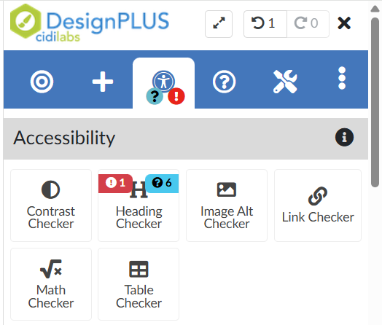
Figure 23: DesignPLUS Accessibility panel displaying the six checkers with numbered indicators for accessibility issues and recommendations

Usability
- Open the Accessibility/Usability tab in the DesignPLUS sidebar to view both Accessibility and Usability tools. The Usability section appears directly below Accessibility and follows the same review process. Detailed information for each checker is available in the DesignPLUS Accessibility and Usability Tools’ webpage.
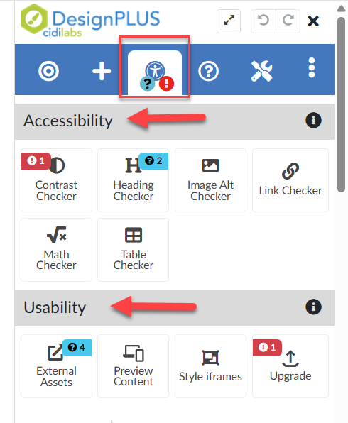
Figure 24: DesignPLUS sidebar showing the Accessibility and Usability sections

PDF Remediation
PDFs can make accessing information difficult. Before using a PDF as a source of information, first consider if other options are viable:
- Using native documents (Microsoft Word documents, Google documents, etc.)
- Replacing PDFs with more friendly documents (Word, Google Docs)
- Moving pdf text directly to a page in the LMS
- Creating multimedia sources to replace PDFs
Avoid using PDFs as sources of information whenever possible. Instead, use more accessible, editable, or non-proprietary formats when available. PDFs should only be used when an alternative format is not available, such as IRS forms or other official documents. Before converting files to PDF, ensure that your original documents are accessible. See Make your PowerPoint presentations accessible to people with disabilities and Make your Word documents accessible to people with disabilities for guidance. If a PDF is your best option, prepare the document for accessibility using the desktop version of Adobe Acrobat. The following steps are the basics of solving most accessibility problems in PDFs. For comprehensive guidance on creating accessible PDFs and verifying their accessibility, see Create and Verify PDF Accessibility.

Running Auto Tag
You will first have to make the document accessible for screen readers. Adobe’s auto-tagging in Acrobat helps by analyzing the visual and text layout of each page, inferring the logical structure.
- Open the PDF in Adobe Acrobat
- Go to the All tools menu
- Scroll down to select “View More” and find Prepare for Accessibility

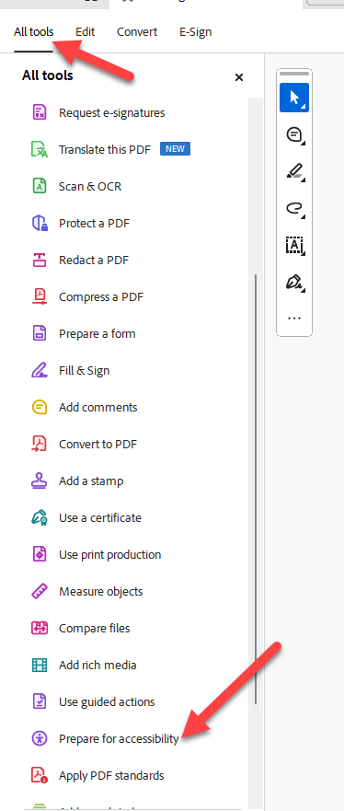
Figure 25: Adobe Acrobat all tools menu
- Select Automatically tag PDF

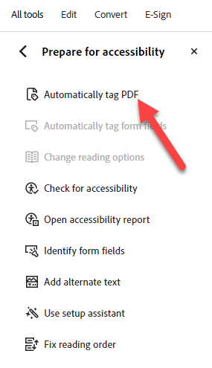
Figure 26: Adobe Acrobat Automatically tag PDF function

Correcting Title and Primary Language
- In the Prepare for accessibility menu of Adobe Acrobat, select the Check for accessibility option
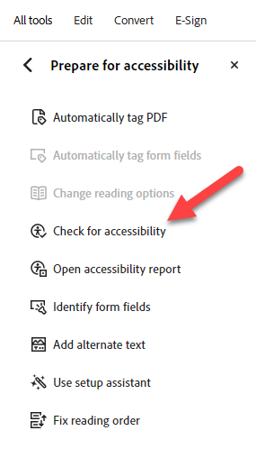
Figure 27: Adobe Acrobat Check for accessibility option
- Leave all settings in the option window as is and select Start Checking.
- Expand the Documents section on the Accessibility Checker panel to see the errors.
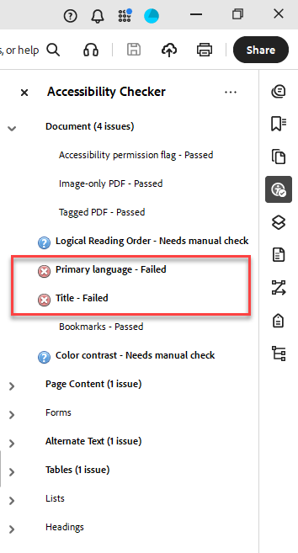
Figure 28: Primary language and Title error on the Accessibility menu on the right-hand side of the screen.
- Right click Primary Language - Failed and select Fix
- Select the appropriate language.
- Right click on the Title - Failed and select Fix.
- Uncheck Leave as is, enter the missing information and select Ok.

Reviewing and Correcting Alt-Text
Since auto-tagging doesn’t always write meaningful alt text, we still must add descriptive alternate text manually. Every image should have meaningful and concise alt-text if they convey instructional content. Decorative images should be marked as such to avoid cluttering the experience for screen reader users. If there is no alt text, that information is effectively invisible.
- Select the Add alternate text from the Prepare for accessibility menu following the steps shown in the images below.
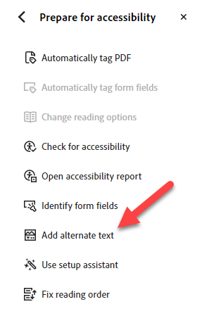
Figure 29: Add alternate text option in the Accessibility menu on the right-hand side of the screen.
- Review the auto-generated alt-text.
- Anything purely decorative, check the Decorative figure box and continue scrolling with the arrow buttons.
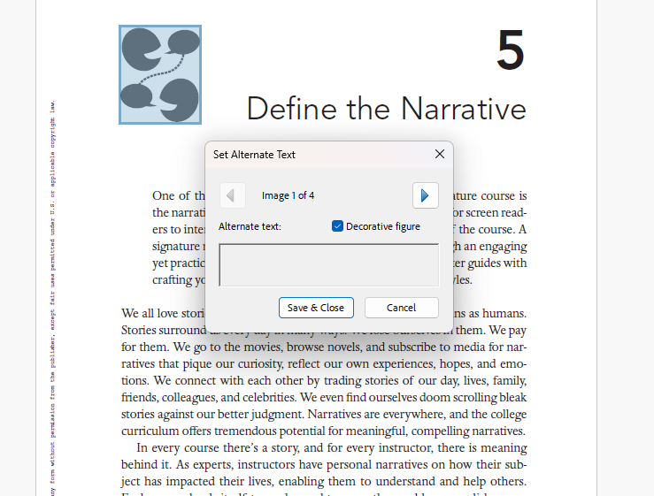
Figure 30: The element highlighted in blue is purely decorative, so check the Decorative figure box.

- For anything that conveys information, enter short, concise descriptions.
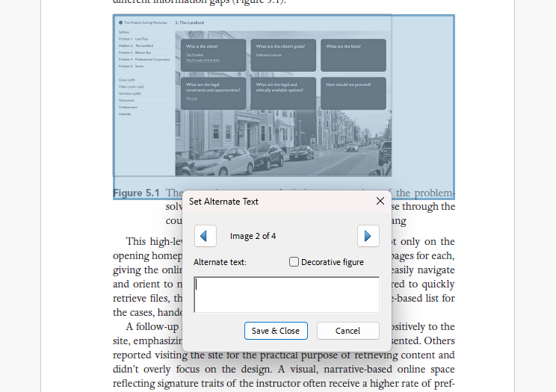
Figure 31: The highlighted image is instructional and requires alternative text.
- Save & Close once you’ve finished.

Correcting Misidentified Tags
It is not uncommon for the auto-tag function to misidentify elements and assign the wrong tag. In order for the document to be truly accessible, these should be corrected. Heading levels are easy adjustments.
- Select the Fix reading order option from the Prepare for accessibility menu.
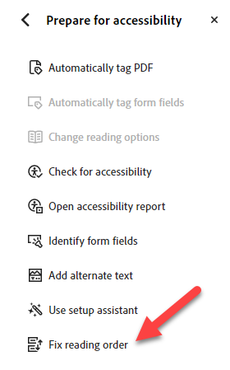
Figure 32. Adobe Acrobat “Prepare for Accessibility” tools panel highlighting the “Fix reading order” option used to adjust the logical reading sequence of content for screen reader accessibility.
- Ensure that the Structure types option is selected.
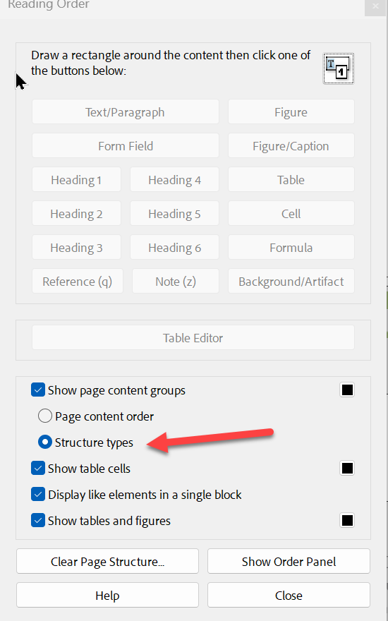
Figure 33. Adobe Acrobat Reading Order panel with the “Structure types” option selected to display document accessibility tags.

- Hover over the structure type tag and click it.
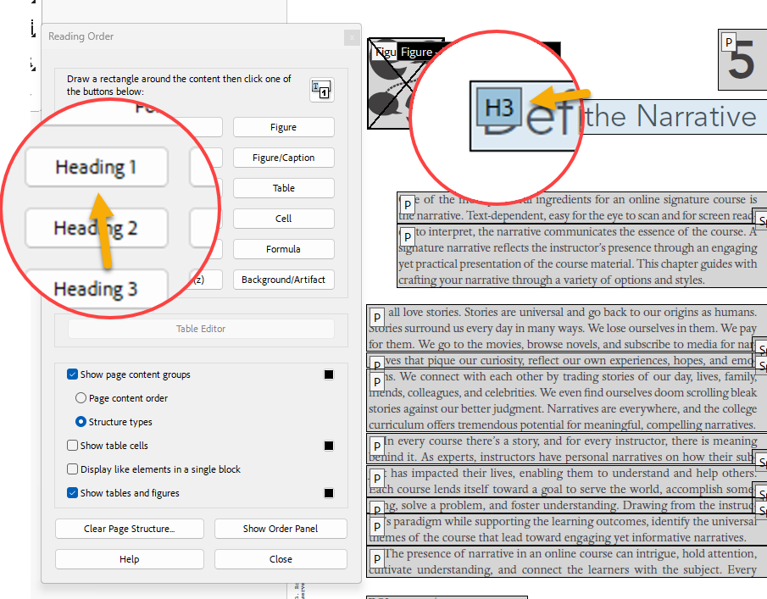
Figure 34. Adobe Acrobat Reading Order tool showing a heading tagged as “Heading 1” to define the document structure for accessibility.
- Select the correct tag type from the option in the Reading Order window.
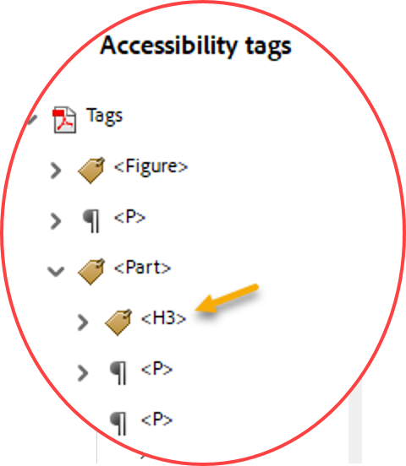
Figure 35. Accessibility tags panel showing the heading structure tag “H3” within the PDF document hierarchy.

Course LMS Navigation and Usability
Course navigation refers to the process of planning, designing, controlling, and recording the movement of learners from one place to another within the course. Instructors should consider the arrangement, clarity, and overall functionality of course navigation from the learner’s perspective. By default, course navigation and usability within the Canvas interface is highly accessible, especially if you make use of the TAMU Canvas template. Keep this in mind as you design and build your course within Canvas.
When customizing course navigations, consider the following:
- Streamlined Navigation: Maintain consistent, logical, and efficient navigation throughout the course that allows learners to move through modules and activities with ease. Consider these strategies:
  - Use simple navigation features such as next, previous, begin/start, close/exit.
  - Test all features to ensure that all links, icons, and windows function correctly and are placed clearly within the course.
- Content Sequence: Sequence the course content in a logical order, and when possible, maintain this order from module to module. The modules feature in Canvas helps instructors organize course content into sections that can be completed sequentially or contextually.
- Naming Conventions: Use consistent naming conventions throughout the course. For example:
  - Modules: Edit the names of modules with a descriptive name. Instead of using the title “Week 1” for the first module, try something specific like “Week 1: Introduction to Writing.”
  - Files: Edit links to files with a descriptive name. Instead of leaving “Writing 101 (Spring 2020).docx” as the item name after uploading a course syllabus, try something like “Writing 101 Syllabus (word).”
- Maximize the Home Page: Provide links or buttons to the syllabus, course modules, and other important resources from the home page for ease of use.
- Student View of Course Navigation Menu: Customize the course navigation menu options for learners; hide or disable any elements that are not relevant to learners by adjusting your Canvas course settings.

Accessible Web Design
Accessible web design means building web content that provides optimal access and inclusion for learners with different learning abilities. In Canvas, Ally will prompt you to use the practices below to make your course accessible:
- Alternative (Alt) Text: Include alt text on all informational images so vision-impaired users receive the same information as sighted users.
- Use of Correct Headers: Use headings with appropriate tags (e.g. H1, H2, H3, etc.) to organize page content. In Canvas, page titles are automatically tagged as Header 1 (H1) so subsequent lower-level headings must be H2, H3, and so forth. This helps learners using screen readers to navigate page content more effectively. In general, the correct and consistent use of the appropriate headers creates pages and documents that are better organized and easier to understand.
- Hyperlink Anchor Text: Use anchor text for hyperlinks that (a) describes what a user can expect when clicking on it and (b) is identifiable as a link by applying a text color and additional text attribute (such as bold, underline or italics).
- Contrast Ratio Between Text & Background: Use an appropriate contrast ratio between text and background which will ensure readability for people with low vision, color blindness and other impairment. The acceptable ratio for contrast is at least 4.5:1 for normal text and 7:1 for smaller text. Larger text has a less strict requirement of 3:1. Additionally, avoid solely relying on color to convey meaning.
- Use of Canvas Editor: Use the Canvas editor to format lists as being either ordered on un-ordered. Screen readers typically detect and announce the number of items in a formatted list.
- Tab Ordering: Apply predictable and consistent tab ordering for learners who rely on keyboard-only navigation. Ensure that all website components are reachable with tabs.
Additional information on Canvas’s accessibility standards can be found on the Instructure Community page.
Note: For detailed instructions, refer to Tips for Getting Started with Accessibility for Websites, prepared by the Web Accessibility Initiative.

Accessible Instructional Media
Instructional videos (such as recorded lectures, demonstrations, and YouTube material), audio content (such as voice recordings and podcasts), and graphics (such as images, infographics, tables, and charts/graphs) can add value to instructional content. When using media in your course, take into consideration the following information to ensure accessibility:
- Videos: When making videos, take care to check graphics and text for color contrast, verbally mention text that appears on screen, and avoid relying on visual elements to convey meaning. If the media makes use of static content (PowerPoint slides, documents, spreadsheets, etc.), the content should follow the static content accessibility guidelines listed below.
- Audio Media: Podcasts, audio instructions, or other audio media should include an accompanying transcript for learners to access. When recording audio to include in your course, you can generate a word-for-word transcript file automatically by using Zoom; this file can then be downloaded and embedded in your course. Note: be sure that any edits made to the audio file correspond to the transcript file.
- Captions: To be fully accessible, all instructional media must be closed captioned. One way to do this is to use YouTube or Zoom to automatically generate captions and then edit the generated captions. Other Media management tools also allow you to edit captions for a video. Consult with your academic department if you need additional help in creating captions.
- Graphics: Images, charts, tables, and infographics should include titles and captions that clearly denote the type of graphic and provide a summary of the information presented. Color contrast should be considered to ensure that text can be easily read against the background. Providing a legend of key components of the diagram may also prove helpful. Finally, alternative text should be added to all graphics with enough detail so that a learner with an impairment may be able to quickly conceptualize the information being illustrated.

Ensuring Accessible Static Content
Static content typically includes Microsoft Office files, PDF files, and links to Google Drive content (e.g., Docs, Sheets, Slides, and other Google applications). All documents should be prepared using the following guidelines:
- Use plain language and avoid figures of speech, acronyms, and idioms.
- Use styles and headings to structure content in a logical order and to preserve tab order.
- Use fonts that are clear and easy to read; choose standard fonts available on all users’ devices, such as Arial, Tahoma, or Verdana.
- Use an appropriate color contrast ratio that aligns with Web Content Accessibility Guidelines (WCAG). Ensure that links can be identified even when appearing in grayscale.
- Use list styles that make a document scannable for every user and allow a screen reader to detect how items are related to each other.
- Use anchor text for links that (a) describe what a user can expect when clicking on it and (b) is identifiable as a link without a need for color.
- For images, use alt text that considers the relationship between the image and its associated content. Also, there is no need to include “image of” in the alt text.
- Ensure that data tables have captions and clearly assigned header rows and table descriptions. Avoid merged cells.
- Set tables as text and not embedded as images. Screen captures of tables are not accessible to screen readers.
- Ensure that tab order is consistent and predictable, and that all elements are reachable by using only the keyboard (without the mouse).
- Ensure that all PDF documents are tagged appropriately, are searchable, and that text is selectable. Do not flatten the document or paste images of text.
Note: For detailed instructions, refer to Tips for Getting Started with Accessibility for Websites, prepared by the Web Accessibility Initiative.

Considerations for Non-Standard Technologies
Technical courses on topics such as optical design, engineering, and software application development usually require learners to learn and use specialized software commonly used in those industries. Wherever possible, it is encouraged that you select accessible software with Voluntary Product Accessibility Template (VPAT) documentation available.
The Federal Government’s Section 508 (General Services Administration, 2018) provides additional information on Voluntary Product Accessibility Template (VPAT).

Considerations for the Diverse Needs of Learners
In addition to ensuring that courses are accessible, it is essential to make your content and learning activities equitable and inclusive. This approach will help learners to explore the course from multiple perspectives, improve interactions, and motivate them to engage in the course content in greater depth.

References
- Adobe Support. (2026). Create and verify PDF accessibility (Acrobat Pro).
- CidiLabs. (n.d.). Best practices.
- CidiLabs. (n.d.). DesignPLUS Accessibility and Usability Tools.
- CidiLabs. (n.d.). TidyUP user guide.
- General Services Administration. (2018). Accessibility conformance report (ACR). Section508.gov.
- Microsoft Support. (n.d.). Make your PowerPoint presentations accessible to people with disabilities.
- Microsoft. (n.d.). Make your Word documents accessible to people with disabilities.
- Shaffer, K. (2025). Accessibility checker and remediation aid: Panorama.
- The Instructure Community. (2025). How do I export a Canvas course?
- The Instructure Community. (2026). What are the Canvas accessibility standards?
- Washington State Board for Community and Technical Colleges. (n.d.). Ally: Canvas accessibility tool.
- World Wide Web Consortium. (2026). Tips for getting started.
- Yuja Help Center. (2026). Getting started with Panorama for instructors.
- Yuja Help Center. (2026). Yuja Panorama LMS accessibility platform: Yuja Panorama overview.
- Yuja Help Center. (2026). Getting started with Yuja Panorama for students.

